Cancellation & Payment Policy:

Due to a high demand for our boarding services & an increasing number of no-shows & last-minute cancellations, we now implement the following reservation and cancellation policy:

In order to accommodate the number of valued customers seeking boarding, we require you to please give us a 48 hours’ notice to ensure that you will not be charged for your entire stay.

I understand that I am responsible for full payment for the days originally reserved regardless if I pick up early.
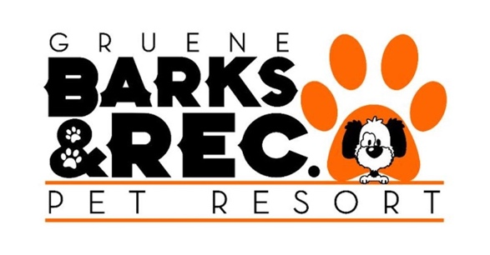

________________________________
Please sign here

